Australian 3D printers on track to print body parts

http://www.abc.net.au/news/wa/
Australian scientists say they have found a way to grow human body parts using 3D printing technology.
The University of Wollongong's Centre for Electromaterials Science is opening a research unit at Melbourne's St Vincent's Hospital where 3D printing will be used to reproduce tissue material.
The bio-fabrication unit scientists have already begun animal trials to reproduce skin, cartilage, arteries and heart valves.

What is 3D printing?
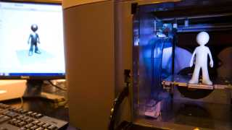
- Allows objects to be created using a computer, software and a 3D printer
- The printer builds the object up layer by layer
- Living cells can be printed using bio-ink to build tissue and organs
- The technology has also been used to make buildings and even guns
Professor Mark Cook says the process could eventually do away with the need for organ transplants.
"It's possible to print devices and structures that can be implanted in human bodies, and these devices can have cells grown on them so that bodily functions can be replicated on these very tiny devices," he said.
"In the future, these sorts of devices will be able to recreate parts of people's joints and bones, conceivably, in the future, even organs."
The Australian technique incorporates the living cells into the actual layered printing process, with a 95 per cent survival rate for the cells.
Team leaders say they anticipate the new tissues will be cleared for use in humans within three to five years.
And they say they plan to move on, eventually, to finding ways of using the technique to print more complicated parts like kidneys and livers.
The centre's director Professor Gordon Wallace says scientists will be recreating complete organs in a decade's time.
"Our ability to print living cells and biopolymers and spatially distribute those in a 3D structure of course sparks the imagination," he said.
"You could see how we could eventually be able to print organs using 3D printing technology."
First posted Fri 3 May 2013, 12:39pm AEST

